Welcome to Charitable Gaming!!!
As a new coordinator for your organization you probably have numerous questions on what the position entails. This training manual was created to help you navigate your way through the various roles, rules, and requirements mandated under your contract. This will also identify what reporting is necessary to ensure you remain in compliance with both the provincial and municipal regulations.
The entire 𝗣𝗼𝗹𝗶𝗰𝗶𝗲𝘀 & 𝗦𝘁𝗮𝗻𝗱𝗮𝗿𝗱𝘀 document has been forwarded to you. If you have not received it, please email me at coordinator.csga@gmail.com
Everyone knows that fundraising is hard! Earning money for your organization takes a lot of time, energy and resources.
Charitable Gaming (known as cGaming) at Community Spirit is one of the best kept secrets in Kingston. It is long-term, sustainable funding. Once a charity is a member of the Community Spirit Gaming Association, they can raise funds for years to come, as long as they continue to fulfill all contractual requirements. This is unlike most funding models which typically end after a few years.
Each one of the two-hour shifts (two hours, two volunteers) is worth, on average, $400 or more! You can see how doing a couple of assignments/shifts a month can add up. That's a pretty sweet fundraiser, with limited cost and no risk! Typically each assignment/shift is two volunteers, two hours.
Let's get started!

Your Charity has signed or will sign a contract with Community Spirit Gaming Association (CSGA). This contract makes you and your organization responsible for complying and participating in all policies and standards, training programs, and other tools that are developed or implemented by your Charitable Gaming Centre Association, Ontario Charitable Gaming Association (OCGA), and OLG.
As information is continually being updated or modified, it is your responsibility to ensure all of your volunteers are kept up to date with all changes. This can be done by distributing Association communications to all of your volunteers, in particular changes or updates. Your charity also needs to have a representative attend the Annual General Meeting (AGM) usually held each September.

This is an example of the contract signed:
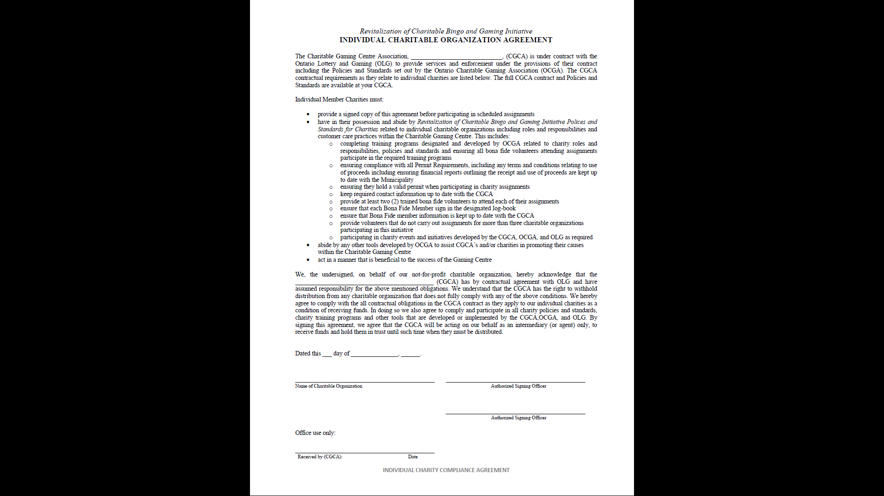

Monthly Gaming Reports for City Hall
Each charity is required to submit monthly financial reports to the Licensing Department of the City of Kingston. These reports must specify the revenue received for the month, as well as any cheques written from that account.
𝗡𝗢𝗧𝗘: These reports must be completed and submitted even if your charity did not have an assignment/shift or write a cheque from your gaming account for the month.
Reports are due 30 days after the reporting month. For example, the monthly report for September should be filed by the end of October in order to give the municipality sufficient time to meet their 60-day reporting deadline to OLG.
You may e-mail your reports to the Licensing Department at (licensingapplications@cityofkingston.ca) For additional information on this option, or if you require additional direction on these reports, please contact the Licensing Department. Please ensure that reports are sent on time or your charity could be suspended or some assignments/shifts withdrawn.
An individual charity permit may also be suspended or revoked if in non-compliance with the approved “Use of Proceeds”. Please contact the Licensing Department for the specific "Use of Proceeds" document related to your charity.

On the next page is an example of the report that needs to be filed with the city.
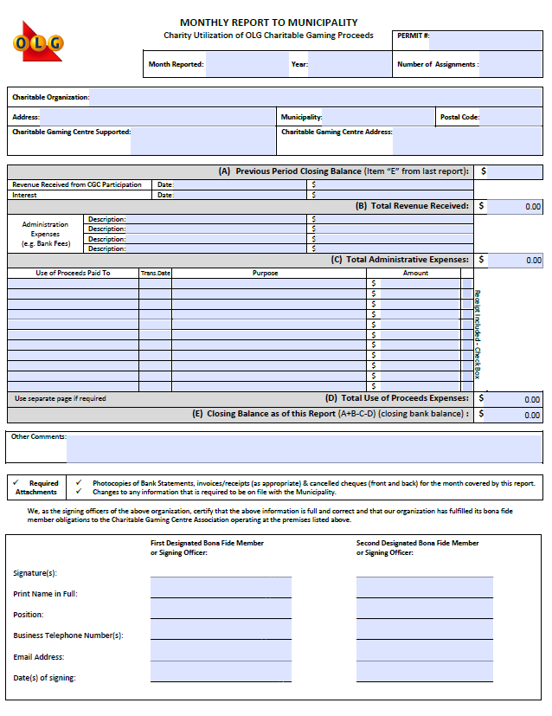

Stakeholder Relationship
It can be confusing with all of the acronyms and business names!
Your charity holds a permit to fundraise at Community Spirit Gaming Centre (the business) and sends volunteers to provide important customer service.
Your charity is automatically a member of Community Spirit Gaming Association (CSGA), which is a charitable association made up of charities like yours. Our job is to support your charity in managing its Charitable Gaming permit. The contact for CSGA is me, Tanya Mohan. I am the Charity Member Manager/Coordinator, I am the Board Representative and I manage all communications between all invested parties. I am also responsible for scheduling and compliance.
CSGA is guided in policies and standards by the Ontario Charitable Gaming Association (OCGA), a provincial organization that advocates for charities or non-profit member organizations like yours, at the provincial level.
Community Spirit Gaming Centre (CSGC) is a privately-owned business that is bound by the policies and standards of Ontario Lottery and Gaming. The employees at the Gaming Centre work for the owner of Community Spirit Gaming Centre. Community Spirit Gaming Association, with the OLG, pays the centre a fee in order to use this site for volunteering.
Community Spirit Gaming Association works cooperatively with Community Spirit Gaming Centre.

Organizational Chart:

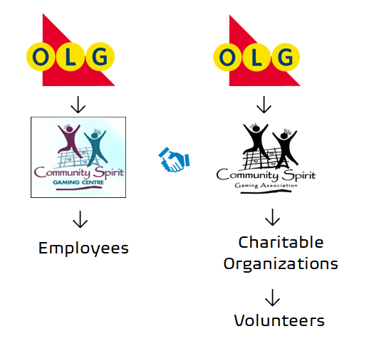
As you can see, each is separate but, we work together. Your earned revenue comes to the Association from the OLG. The Association pays a certain amount of expenses out of the Earned Revenue to the Gaming Centre and the rest is distributed to the charities because they are members of the Charitable Gaming Association. How much revenue each charity receives depends on the number of assignments versus infractions each charity has incurred over the course of the month. I will cover infractions and scheduling in this manual as well.

Dress Code
Your volunteers are required to comply with a dress code. They should wear logoed, collared shirts OR vests which clearly identify your charity (purchasing these for your volunteers is considered an eligible use of proceeds expense). This is a great way to let customers know which charity is volunteering during shifts, and helps build familiarity with your charity. New volunteers and charities have 45 days to get uniforms.
Here is the required dress code:
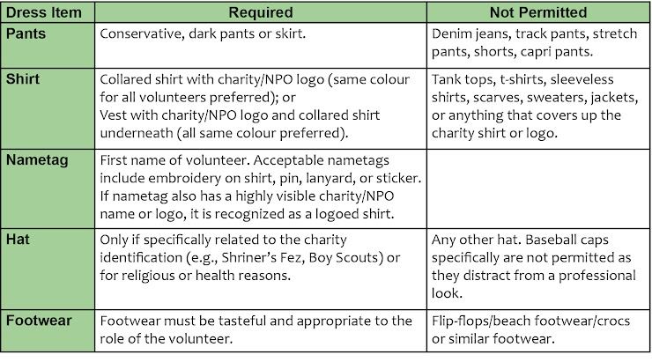

Charity Participation/Engagement

Participation and Engagement is a requirement under your contract. Charitable Organizations must, at minimum complete two of the following requirements during a twelve month period. This is typically letting your followers know how funds raised in the gaming centre benefit your charity and the community as a whole. These must be advertised in the same community/audience as the charitable gaming centre. Failure to comply within prescribed timeframes will result in financial and escalation policies outlined in B.12 and C.12 of the Policies and Standards and may result in removal from CGCA membership.
• Plan / participate in a charity event at the Charitable Gaming Centre
• Host an off-site cheque presentation with the CGCA (their AGM, event, etc.)
• Attend or host a photo-op / chq presentation / media event at the Charitable Gaming Centre
• Reference the Charitable Gaming Centre in Media Articles (Newspaper, Local News, etc.)
• Tag the Charitable Gaming Centre on Social Media posts
• Promote the Charitable Gaming Centre in publications (Newsletter)
• Charitable Gaming Centre logo placement
o organization’s website or letterhead
o materials (poster / brochure / program / etc.)
o on display cheques given to other groups (service clubs)
o on buildings / vehicles o outdoor advertising / signage
If you have any ideas or suggestions on additional items that could help achieve charity awareness, please let me know.

Administration/Permit Information
Charities belonging to Community Spirit Gaming Association (CSGA) are 𝗶𝘀𝘀𝘂𝗲𝗱 𝗮 𝗽𝗲𝗿𝗺𝗶𝘁 𝗯𝘆 𝘁𝗵𝗲 𝗖𝗶𝘁𝘆 𝗼𝗳 𝗞𝗶𝗻𝗴𝘀𝘁𝗼𝗻 for a one year period – April 1st to March 31st. These permits are required in order to fundraise at Community Spirit Gaming Centre. There is no cost for a permit.
Prior to the expiration of the current permit, the City of Kingston's Licensing Department will contact each member charity by e-mail and request information required for the next permit period.
The Bingo Coordinator of each charity completes the permit application, has it signed by two executive members of their organization, and returns it to the Licensing Department. Each charity is also required to provide the Licensing Department with complete annual financial statements.
Once all of the required information has been received by the Licensing Department, the charity will receive their scheduled bingo assignment dates for the next scheduling year.

Permits: The Licensing Department of the City of Kingston will issue each permit and your assignment/shift schedule by e-mail and snail mail. Once a permit has been received, it is the responsibility of the charity Bingo Coordinator to ensure that a minimum of two trained, bona-fide members are scheduled for each of their assignments/shifts. This allows individual volunteers to schedule their assignments/shifts into their own personal calendars and to confirm their availability.
Front Page of Permit
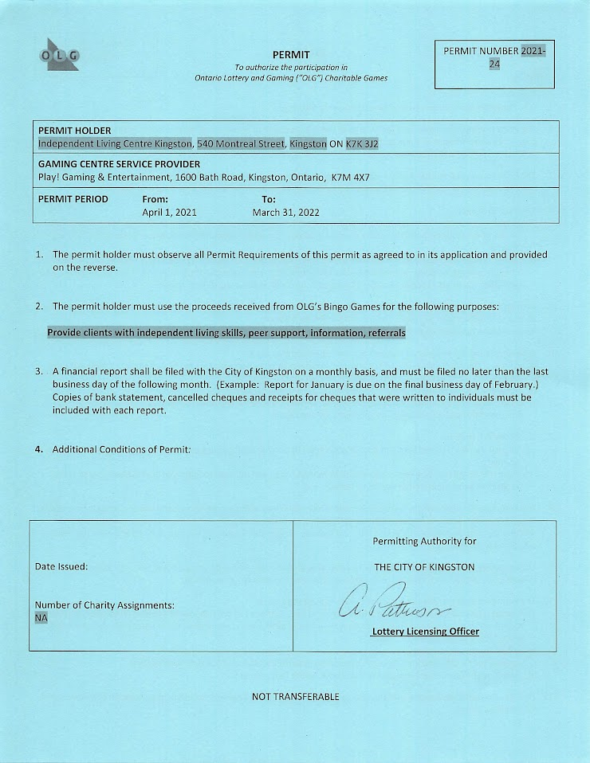
Back Page of Permit
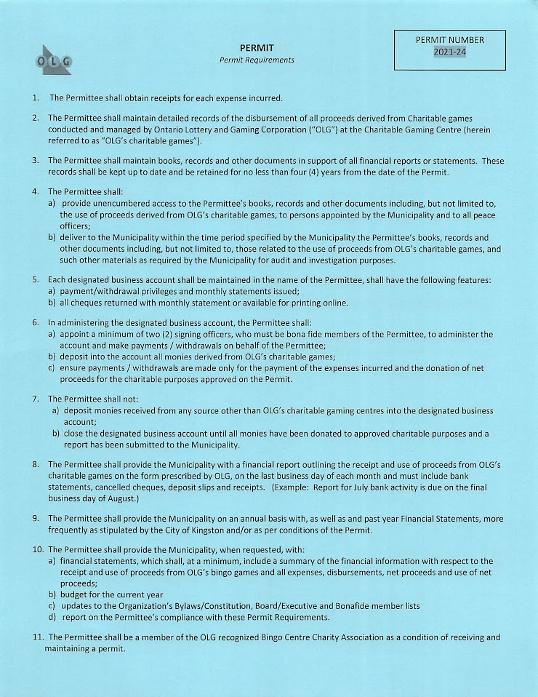

Bonafide Members
According to the Policies & Standards for Charities, permitted charities must provide at least two trained bona-fide volunteers to perform roles and responsibilities in the charitable gaming centre. This is a contractual requirement. Without the participation of bona-fide members, participating charities are ineligible to receive funds from the CGCA (charitable gaming centre association) and OLG.
𝗕𝗼𝗻𝗮-𝗙𝗶𝗱𝗲 𝗠𝗲𝗺𝗯𝗲𝗿 𝗗𝗲𝗳𝗶𝗻𝗶𝘁𝗶𝗼𝗻
A bona-fide member, for the purposes of participating in assignments/shifts for a permitted charity, must be an individual who:
• either meets the membership criteria set out in the constituting documents for the charity or;
• an individual who volunteers in another capacity within the charity other than cGaming
• has been admitted as a member in accordance with the requirements set out in the constituting documents;
• remains a member in good standing in accordance with the constituting documents;
• participates in the activities of the charity; or
• is a parent/relative of an active member or participant under the age of 18 in the charity.
Paid employees from the charitable organization may be used for assignments/shifts providing this is not their primary role within the charity.

Volunteers are not permitted to receive any financial compensation/honorariums for participating is an assignment/shift
A bona-fide volunteer participating in the cGaming model may only volunteer to carry out “assignments” for a maximum of three unique Permits (charities) issued to charitable organizations in Ontario within a calendar year. A volunteer in breach of this policy will not be recognized as a trained bona-fide volunteer for the charity and financial penalties will be incurred.
If one of your volunteers wants to volunteer for more than just your charity, please ask me for a Volunteer Confirmation Form in order to have them fill it out. Once completed (identifying which three charities the volunteer wants to volunteer for), return this form to me as soon as possible at: coordinator.csga@gmail.com

To keep numbers manageable and to properly facilitate training and customer service standards, the number of Bonafide Members each charity may use during a 6 month period must be no greater than 20 volunteers. Volunteers can be added at any time as long as there are not already twenty listed, but deletions can only be made twice per year. I will advise when these deletions can take place.

Schedule and Assignments
The number of assignments/shifts for each charity is decided by the Licensing Department of the City of Kingston, in combination with the "Timeslot Preferences" form emailed to charities several months prior to the start of that scheduling year. Once all of the information has been received for your new permit, your schedule will be emailed to your charity. This will show all of your assignments/shifts scheduled for the permit period.
After your permit has been received, it is your responsibility to schedule trained, bona-fide volunteers for each of the scheduled assignments/shifts for that permit period. This allows individual charity volunteers the ability to schedule their bingo assignments/shifts into their own personal calendars and to ensure their availability when they are required to volunteer.
𝗡𝗢𝗧𝗘: Remember there is a maximum of 20 volunteers allowed to fill assignments/shifts. Names on this list may only be deleted twice per year. This list must be provided to the Charity Member Manager/Coordinator whenever there is a change. It is your responsibility to keep this list up to date and current so that it may be provided to the Charity Member Manager/Coordinator whenever it is requested.
Hints to Avoid No shows/Non Attendance
- Have each pair of volunteers scheduled to cover an assignment/shift, share their cell phone numbers and call or text each other when they are on their way to the gaming centre.
- Designate someone from your organization to email/call/text the scheduled volunteers the night before their shift.
- Use a three-person system for volunteering. Two volunteers are scheduled for each assignment but, there is a stand-by alternate that can be available last minute in case one of the scheduled volunteers becomes unavailable.
What happens if we can’t attend an assignment?
For various reasons, sometimes a charity has a conflict and is unable to carry out one of their scheduled assignments/shifts. In this case, the charity must contact the Charity Member Manager/Coordinator providing a minimum of five (5) days' notice (with additional notice much appreciated). I will attempt to have another charity cover the shift and the original group will not be entitled to the revenue. If sufficient notice has not been given (5 days) it will be considered a “no show” and financial plus infraction penalties will be incurred.

Training
According to your contract, all volunteers must be trained before volunteering at the gaming centre. Training is twofold: first there is an on-line training course to which a link will be provided. This should take approximately 30 minutes to complete.
After the on-line portion is completed, the new volunteer must then shadow a more experienced volunteer from your charity. This means they will be the third person attending one of your assignments/shifts. At that time, a checklist must be completed, signed by both the new and experienced volunteer. The checklist will be supplied by me and must be returned to me once completed. Your charity will have to wait for confirmation of completion to adding to your bona-fide list of volunteers.
𝗡𝗢𝗧𝗘: Accommodations will be made for charities with no experienced volunteers. This can be worked out on a case by case basis for what is best in each situation.
As your charity’s coordinator, you must ensure that your volunteers complete the entire training program before volunteering for an assignment/shift or financial and non-compliance penalties will be incurred.
Under the provisions of the contract, Community Spirit Gaming Association (CSGA) is responsible for ensuring all charities are aware of, and conform to, the mandated roles and responsibilities. Failure to do so can result in financial or other repercussions as listed in the Policies and Standards for Charities.
Any revenue deductions resulting from penalties assessed in a month is distributed to the rest of the CSGA charities (that have not incurred any penalty) on a pro-rated basis.
Non-compliance also includes an escalation process. If your charity/ has four infractions within a 12 month period, the City of Kingston will issue a suspension of a certain number of assignments/shifts depending on the type of infraction. All infractions stay on your record for one year from the date of the infraction.

List of Infractions:
Financial repercussions for non-compliance include:
• Dress code – ¼ deduction of assignment revenue per occurrence
• One trained volunteer attending – ½ deduction of assignment revenue per occurrence
• No trained volunteers attending – loss of 1 full assignment revenue
• Trained volunteer arriving late or leaving early – up to ½ deduction of assignment revenue per volunteer based on portion of assignment missed
• Roles and Responsibilities or non-compliance with Policies and Standards not listed in
B.12.c – ¼ of assignment revenue deducted per occurrence

Escalating Infractions process is as follows:
First Infraction:
A designate from the CGCA will have a verbal discussion or written communication (may include email) with the principal contact on file for the charitable organization and attempt to resolve the problem(s). The communication will inform the group that this is step one of an escalating process.
Second Infraction:
A designate from the CGCA will ensure written communication is sent to the charitable organization outlining the specific concerns and policy explanation.
Third Infraction:
The CGCA board or designate will discuss with the organization infractions and policies to resolve concerns. The CGCA will notify and engage the municipality in the discussion which may result in additional action related to the organizations Permit.
Fourth Infraction:
Municipality directed to suspend / revoke permit with discussion from CGCA. A formal letter must be sent to the principal officer of the organization notifying
them of action taken and the organization is removed from the schedule.

